10.29: a) 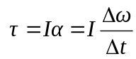
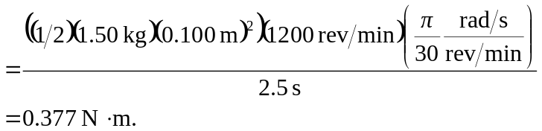

- 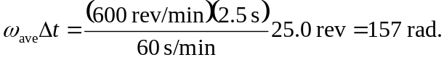
c) 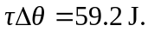
d) 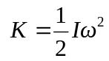
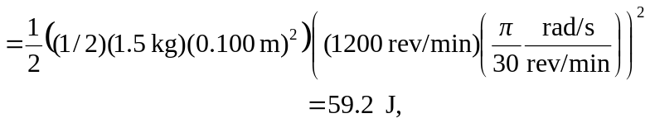

the same as in part (c).

